Prepared by Karen Charman for the unit team

Introduction
Welcome to EAD105 Applied Community Project. I am looking forward to spending the next twelve weeks with you. This is a new unit and I hope it is one that excites you as much as is does me. I am interested in your ongoing feedback and will do my best to be responsive to your needs as a student along the way.
This unit is part of the burgeoning and exciting area of study that investigates the uses of narrative. Our focus will be on the content of narratives but also on the forms narratives take such as photographs and museums. The importance of individual memory and its contribution to our sense of collective, and therefore community, memory cannot be underestimated. In this unit we investigate the origins of museum spaces to explore the question of the role and importance of public spaces such as museums. More recently museums have undergone a shift in what is remembered and what is represented. Two good examples are: the Immigration Museum, Melbourne; and Flagstaff Hill Maritime Village (museum), Warrnambool.

Aims
In this unit you will gain an understanding of the individual, social and community importance of narratives. You will be introduced to critical perspectives on culture and traditions contained in narratives. You will learn to analyse a number of forms and respective content of narratives such as photographs, objects and museums. You will conduct archival research. You will apply this knowledge to a project in a community setting.

Objectives
When you have completed the unit, you should be able to:
- understand some of the ways narratives are structured
- analyse narratives in different forms
- conduct archival research
- understand and describe the aims and workplace practices of at least one community organisation.
- complete a project in a community setting.

Topic 2 Ways of representing narratives

Objectives
When you have completed this topic, you should:
- have an overview to the possibilities and limitations contained in forms of representation
- have an appreciation of photographs, objects and museums.

Consideration of form
Narrative is represented in numerous forms such as photography, museums, film and literature. Our focus for this topic is narratives and how they are told through photographs, objects and museums. All of these forms of representation can tell the same story. However, each form has possibilities and limitations.

Reading
Please read:
Kavanagh, G 2000, ‘Dream spaces, memories and museums’, Dream spaces: memory and the museum, Leicester University Press, New York, pp. 1–8.
The reading for this week explores the role of memory and the meaning of objects. According to Gaynor Kavanagh (2000), what is the link between museums and humanity?

Topic 3 Photographs as narrative and objects

Objectives
When you have completed this topic, you should:
- understand ‘visual literacy’ through the examination of photographic images
- understand the principles of photographic composition
- be able to discuss the basics of culture and tradition.

What is culture? What is tradition?
As you can see from the Raymond Williams (1976) extract, the meaning of ‘culture’ has changed over time. The cultivation of a human being, a cultured person or someone’s cultural background are examples of the different meanings of this word. In our contemporary world the term culture, in its broadest application, is something that we are all embedded in. Each aspect of our life is determined by different cultural codes. Simply expressed, when you are at university you are participating in a particular culture with its own set of requirements, when you go to work there are other expectations. People talk about the ‘culture’ of a workplace. If you are new to a particular situation often you need to be told about the culture. Of course culture can also be a part of religious beliefs or practices that are part of other sorts of cultural groupings such as class or race. Traditions and culture are related terms. Culture is made up, in part, of traditions. You might have tried to explain why your family or friendship group does something in a particular way and your answer could be ‘it’s a tradition.’
Knowledge of a family member or something that has occurred in your family can also become a tradition in the sense that you pass it on. Every family has numerous stories, a great-uncle, a great-aunt or great-grandparents whose stories are retold; these are famous stories in the family. These stories don’t even have to be a few generations removed; you may marvel at stories about your parents! If the story, whatever it is, is retold and you have committed it to memory and in all likelihood will pass it on, this is a form of tradition. Why do these stories matter? Stories give us a sense of place and contribute to our identity. Stories from the past give us a sense of continuity.

Photographs
Photographs are objects that represent an image. The analysis of a photograph occurs on a number of different levels. It is possible to locate the era of a photograph, by the paper the image is printed on as well as the composition. We will look at examples of old photographs to see what historical stories these objects reflect both as form and as content. The other way a photograph can be analysed is the feeling the image evokes. A photograph, just like any object, may generate associations for you. The way a subject might be dressed, their hairstyle or even the photograph’s setting may have meaning for you even if you don’t know the people. Famous photos of tragedy might be imprinted in your memory. Personal photographs generate meaning from the story you associate with them. The feeling can be immediate as though the captured image happened only yesterday. Photographs the can be an extension of what Kavanagh (2000) in ‘Dream spaces, memory and the museum’ (see previous topic) is referring to in the experience of other objects in a museum.

Reading
Please read:
Howells, R 2003, ‘Photography’, Visual culture, Polity Press, UK, pp. 151–70.
Williams, R 1976, ‘Culture’, Keywords: a vocabulary of culture and society, Flamingo, London, pp. 76–82.

Topic 4 Assessment and class presentation
This week you will present a photograph to the class. The photograph that you choose must be from a time either before you were born or from a time you can’t remember. You need to find a photograph that has a story attached to either the actual day the photo was taken, or to the people in the image.
Assignment No. 1 Photograph and Object Presentation and Write Up. 20%
MARKING CRITERIA
What the Assessor will be looking for when marking this assignment
When you present your chosen photograph you must describe the image and speak to the story associated with the photograph. When you present your chosen object you will need to describe the object and the associated story.
Your written piece will cover a description of the photograph you presented and the story you told. The write up of your chosen photograph must pay attention to presentation and formatting. This includes grammar and spelling. Your submitted piece must have 1.5 spacing and a clear margin down the left hand side for comments. Your written piece must be no less than 400 hundred words.

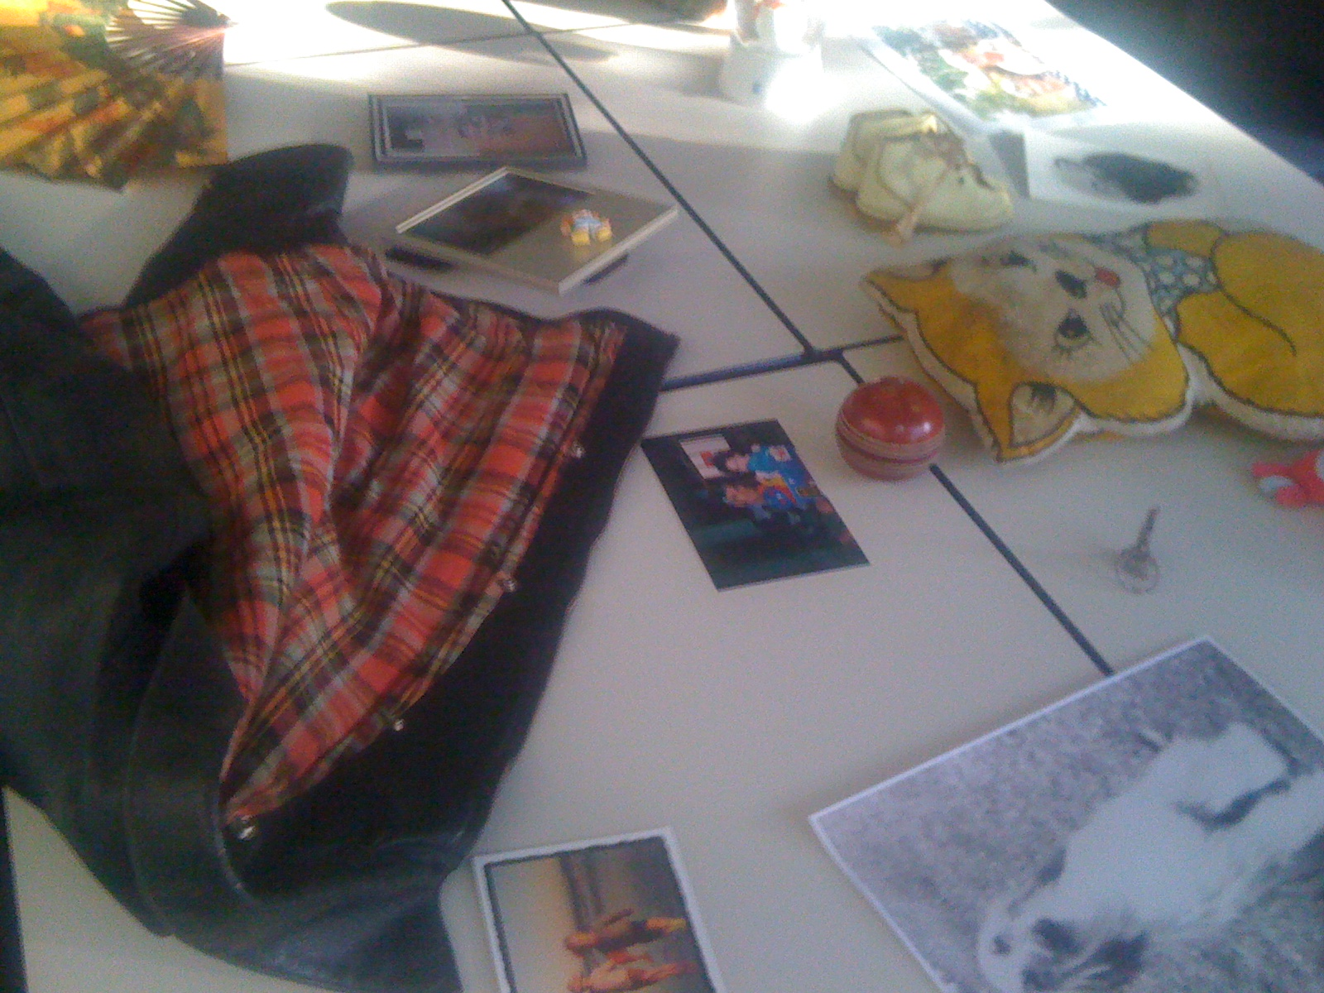

Topic 5

What is a museum?

Objectives
When you have completed this topic, you should:
- have a basic understanding of the historical formation of museums
- be able to discuss the changing forms and content of museums
- have investigated the ongoing contemporary shift in museum form and content from broad understandings of historical events to the narratives of communities.

Museums: past and present
Museums are emerging as sites that are preserving cultural memories. We could argue that museums are in a state of transition and like all change the varied examples of what they are transitioning into are yet to fully materialise. Eilean Hooper-Greenhill writes in regard to these changes in English museums ‘new ideas about culture and society and new policy initiatives challenge museums to rethink their purposes, to account for their performance and to redesign their pedagogies.’ (Hooper-Greenhill, 2008, p. 1)
In its initial inception the museum as an exhibition space was strongly infused with nationalism. Sharon Macdonald (2003, p. 1) writes:
The emergence of the nation-state, the public, and the public museum in the late eighteenth century, were intimately bound together. The French Revolution of 1789, regarded as a key moment in the dawn of the nation state era in Western Europe, was a revolution of ‘the people’ which saw the replacement of an aristocratic order with a new more horizontal and democratic conception of a collectivity of equals.
What this meant was previously privately owned art that hung in aristocratic homes began to be hung in public spaces. The idea that art was only for the privilege of the elite was broken. Macdonald goes on to point out that this was a moment of culturing the public: for bringing high culture to the masses and more importantly for attempting to constitute this notion of ‘public’ in the egalitarian sense of the word. This state of exhibition practices in relation to art still exists today. In contemporary society if one very rich person had exclusive access to a famous painting this would not be tolerated. Wealthy people may continue to own the art but they would be requested to loan the work for exhibition so that the ‘public’ could have access to it.
However, the display of art is not the only role of museums. By the end of the eighteenth century this idea of nation and culture are strongly reflected in the museum. As Benedict Anderson (1991) has pointed out, ‘thinking of oneself as a member of a national public – envisaged like a large “team”, “family” or community made up of thousands or millions of people most of whom one would never meet – entailed a particular feat of the imagination’. Nevertheless, over time the sorts of things that we, as a collective of people living in a nation, were encouraged to feel proud of were displayed in museums. Museums speak to us as a nation.
In Australia the first national museum was the Australian War Memorial in Canberra. This war memorial was built after the First World War, the war that saw ‘Australia come of age’. The former Prime Minister, John Howard, still talks about that war, specifically the sacrifice made at Gallipoli, as Australia coming of age as nation. The National Museum, also in Canberra, has been criticised and an inquiry has been held into aspects of exhibitions. The criticism was that this museum presented a ‘black armband’ view of history. In ‘Museums as agents for social and political change’ Dawn Casey (2001) discusses the difficulties of representing multiple histories in the National Museum. What this difficulty has largely consisted of is the lack of a ‘… “master narrative”—a strong, authoritative voice with a simple chronology of civilization and progress.’ (p. 231) Reflecting multiple narratives means representing the stories of Indigenous Australians. In many cases these stories do not show white settlers in a positive light; hence the term ‘black armband’. So museums now have become contested sites.
What sorts of items should be displayed and what sort of displays represent Australia as a nation? These are complicated questions with no simple answers. However, there is still a need for public sites of collective memory.

References
Anderson, B 1991, Imagined communities: reflections on the origin and spread of nationalism, Verso, London.
Casey, D 2001, ‘Museums as agents for social and political change’, Curator: The Museum Journal, vol. 44, iss. 3, pp. 230–6, Wiley InterScience online, retrieved 28 June 2010.
Hooper-Greenhill, E 2008, Museums and education: purpose, pedagogy, performance, Routledge, New York.
Macdonald, SJ 2003, ‘Museums, national, postnational and transcultural identities’, Museum and Society, vol. 1, no. 1, retrieved 22 June 2010.

Topic 6 Immigration Museum

Objectives
When you have completed this topic, you should:
- appreciate the narratives of immigration
- reflect upon, and have an understanding of, the aesthetic construction of the Immigration Museum, Melbourne.

Place, identity and citizenship
A sense of place, identity and ultimately the responsibility that comes from active citizenship are key factors in preventing social fragmentation and ensuring a cohesive community. Benedict Anderson (1991) has identified the origins and nature of a national sense of identity as grounded in an imagined distinct historical continuity. What might constitute historical continuity in contemporary Australia? Distinct and accepted historical markers need to be acknowledged but space must be made for contemporary imaginings.
Immigration affects everyone who lives in Australia; whether it is in a very immediate sense, as a newly arrived immigrant, the preservation of stories that are intricately bound up with the preservation of culture from another place, or the decimation of culture as in the case of Indigenous Australians. Much of our collective identity can be located within these paradigms. Australia’s immigration story has the potential to provide continuity in ways that other national narratives may not.

Reading
Please read:
Szekeres, V 2007, ‘Representing diversity and challenging racism: the migration museum’, in S Watson (ed.), Museums and their communities, Routledge, New York, pp. 234–43.
Young, L 2001, ‘Federation flagship’, Meanjin, vol. 60, iss. 4, December, pp. 149–59, Expanded Academic ASAP database.

Activity
We will be visiting the Immigration Museum in Melbourne. You must download an audio guide for this visit and complete a reflective piece of writing. Full details of this assessment task can be found in the unit guide on DSO.

References
Anderson, B 1991, Imagined communities: reflections on the origin and spread of nationalism, Verso, London.
Assignment No. 2 Reflective Piece on the Museum. 20%

MARKING CRITERIA
What the Assessor will be looking for when marking this assignment
Download the audio guide for the visit to the Immigration Museum. http://footprints.edublogs.org/2008/02/21/stories-of-the-diaspora-a-guided-visit-to-the-immigration-museum-melbourne/

Take notes as you walk through the different spaces at the museum. You don’t have to submit your notes they are to assist you in your write up. Your written submission must clearly reflect on the guided audio tour of the Immigration Museum. You must also integrate/draw on one of these two readings: Kavanagh, G 2000, ‘Dream spaces, memories and museums’, Dream spaces: memory and the museum, Leicester University Press, New York, pp. 1–8. Szekeres, V 2007, ‘Representing diversity and challenging racism: the migration museum’, in S Watson (ed.), Museums and their communities, Routledge, New York, pp. 234–43.

Clear expression and attention paid to spelling and grammar. Your written submission must have 1.5 spacing with a margin on the left hand side of the page for comments.

Topic 7 Seminar at Flagstaff Hill Maritime Village

Objectives
When you have completed this topic, you should:
- be able to conduct archival research
- appreciate working in the exhibition space at Flagstaff Hill
- have prepared an exhibition plan.

Exhibition space
This week our work begins in the exhibition space at Flagstaff Hill Maritime Village. We will have a tour of Flagstaff Hill and attend a seminar. The seminar will be an introduction to the work undertaken at this museum. The roles of people who work at the museum will be familiar from our visit to the Immigration Museum; however, there are some differences. You are required to take note of any differences or similarities between these two sites.
After this week we swap our structured classes for you to work on the exhibition. Your focus will shift from accumulating knowledge about museums and forms of representation to the construction of an installation that tells a narrative of immigration. You are faced with the question regarding the best way to tell the story your group has decided upon. Your installation may include combinations of objects, photographs, interviews recorded on a DVD and/or spoken voice.
Weil, S 2007, ‘The museum and the public,’ in S Watson (ed.), Museums and their communities, Routledge, New York, pp. 32–46.

Topics 8 & 9 Project work

Objectives
When you have completed these topics, you should:
- have experience in working as a member of a group
- fulfil your designated role within the group
- acquire strategies to trouble-shoot problems that may arise.

Group communication
These two weeks are crucial in meeting the aim of constructing your narrative of immigration. In this section of the unit you are required to be self-directed. You need to keep in mind that unless every member of the group is doing their ‘bit’ then your group project will not work. Communication is important because you may well be off doing aspects of your group work alone. You may choose to communicate via the unit’s DSO site or as a group you may have a preference for communicating in another way but you must communicate with each other.

Topic 10 Group presentation

Objectives
When you have completed this topic, you should:
- know where your group is up to
- be aware of what work still needs to be done
- have a realistic plan for finishing your exhibit by the deadline.

Work in progress
This week we meet up as whole group in the exhibition room at Flagstaff Hill. You are required to present an update of your work in progress to other members of the class. This is a way of gauging where your group is up to relative to the other groups and, more importantly, it is a way of checking that everyone is on track to meet their deadline.

Topics 11 & 12 Exhibition and launch

Objectives
When you have completed these topics, you should have:
- planned and completed an exhibition
- organised and participated in a launch.

Final weeks
Weeks 11 and 12 are the final two weeks of the unit. In Week 12 we will be launching the exhibition. This launch will be a public event. It will be an ‘all hands on deck’ period of time and you can expect to get frustrated and overwhelmed, but also very excited. You will have contributed to an exhibition in a museum setting!
If you reflect on what you have learnt in this unit, you will realise that access to a museum space and contributing to part of what a museum is exhibiting is a relatively new shift in Australian museums. Determining the way a narrative is told through an exhibition is one of the strongest ways to learn multiple aspects of knowledge. Bringing to ‘life’ another’s story in a public space will alert you to the way meaning is constructed, the importance of civic engagement and our responsibility for collective memory.
These stories are as significant as the so-called ‘great’ stories of people in Australian history. You have contributed to what is remembered!

Assignment No. 3 | Journal 20%
MARKING CRITERIA
What the Assessor will be looking for when marking this assignment
800 words total spread over unit duration—weekly reflection on the project.

You must write something each week that addresses the following question: What have been the challenges and high points of the work we are undertaking? You must also indicate the parts of the project that you are working on.

Assignment No. 4 | Exhibition and Launch 40%
MARKING CRITERIA
What the Assessor will be looking for when marking this assignment
That you attend the work in progress session.
That you are contributing to the overall project.
Attendance and participation at the launch.

