Start of Semester | End of Semester
Demographics  Male= 2 Female=13  Age  University  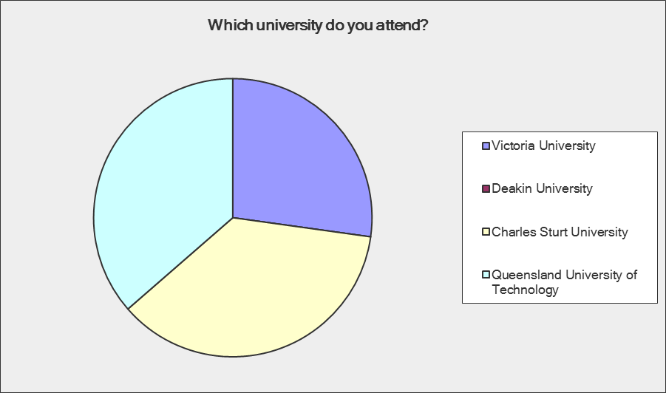  How many times a year would you visit a museum?  < or equal to 1 61.9%  2-4 28.6%  5-7 7.7%  Greater than 8 7.7%  All participant had previously visited a museum | Demographics  Male= 6, Female= 27  Age  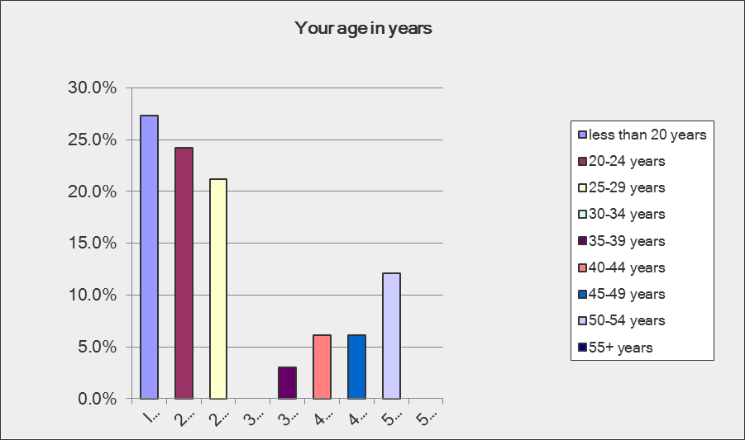  University  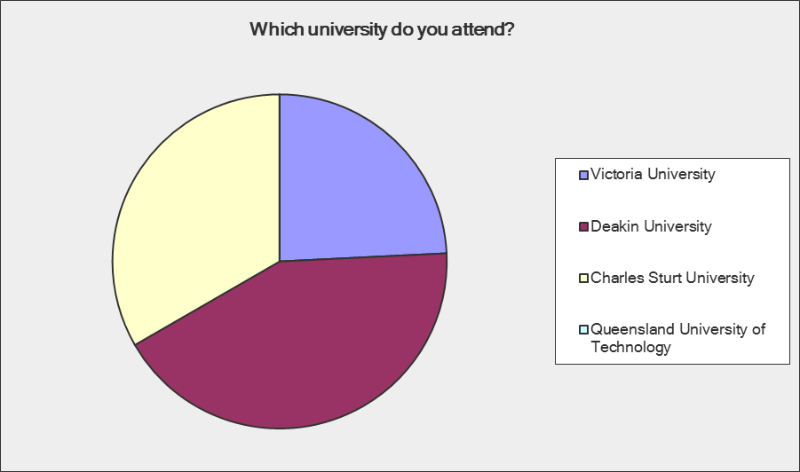  How many times a year would you visit a museum?  < or equal to 1 41.4%  2-4 51.7%  5-7 6.9%  Greater than 8 6.9%  All participant had previously visited a museum
Purpose of visit to museum Themes  Education (9)  Personal Interest (6)  Spending time with family and friends (6)  Relaxation/Enjoyment (4)  What do museums do Themes  Education (11)  Resource for knowledge on past/ present and future (9)  Store information and display artefacts (6)  Entertainment (3)  Story telling (1)  “ they are resources for information on selected themes of knowledge, social history, history, science and technology focused museums”  What do you learn in museums  People places and culture; past and present (8)  History of individuals and of society (4)  History in general (3)  Experiential access to information and knowledge (3)  Immigration (2)  General education (1)  “Museums may be artistic, anthropological or scientific in nature, among others, they provide us with the opportunity to engage with history/historical constructs, archaeology, design, scientific processes -any number of systems and chronologies that surround us. They provide experiential access to information.”  What did you like most about museums visits  The content of exhibitions (5)  Learning about history (4)  Interactive nature of exhibition (3)  Aesthetics of museum (2)  Museum shop (2)  Day off school (2)  The guide (1)  Presentation of work (1) | Purpose of visit to museum Themes  Education (13)  Spending time with family and friends (12)  Personal Interest (6)  Relaxation/Enjoyment (4)  What do museums do Themes  Education (12)  Store information and display artefacts (11)  Resource for knowledge on past/ present and future (10)  Story telling (1)  “I believe that they capture history and display it in a way in which one can learn from a variety of ways: such as emotional, visual, aural, and by reading and going on tours”.  “Many are scrounging for a new way to engage, the good ones are interesting and interactive for all ages regardless of the topic. They aim to impart specific and expert knowledge of a subject.”  What do you learn in museums  People places and culture; past and present (8)  History in general (7)  Experiential access to information and knowledge (5)  History of individuals and of society (3)  Immigration (1)  General education (1)  “There are a wide variety of learning experiences provided by museums covering a vast array of topics, such as, history the environment, nature and wildlife, physics, prehistoric ages, space and technology.”  What did you like most about museums visits  Interactive nature of exhibition (9)  Learning about history (9)  The content of exhibition (4)  Presentation of work (1)
At the end of the second survey respondents were asked:

How did the visit impact your learning?
Themes discussed impact on:
- educational level (4)

“In this subject, I was remembering the times I visited museums in school and how the added to my engagement and extended my learning. I love museums and the opportunity to include visits in my teaching lesson plans has really excited me.”
- personal level (1)

- greater understanding and a new way of thinking (6)

“Chifley house was good to relate to the visual arts curriculum. Good to try and bring in new ways of thinking.”

- maximises learning opportunity (2)

- minimal impact (4)

Was the visit a worthwhile venture?
All the participants agreed that it was a worthwhile venture. Themes included the importance of visits as novel, interactive forms of learning.

“Yes. I believe museums and libraries are a dying commodity. They are, in a sense. becoming history themselves as they seem to be becoming unpopular. I believe it is important for a person to understand the world they live in, and that involves history found in museums and libraries.”

“For students, a more hands-on (physical experience), can create a more lasting impression than looking at books, or going online in a classroom.”

“ I definitely think these visits are integral to learning, especially as many students may not encounter these places in their lives outside of school. The resources for learning are abundant and providing this opportunity in curriculum will endeavour that students continue to learn and search for knowledge through their lives.”

“ YESSSS!!!!! Utilizing museum and library facilities gives me greater opportunities to learn how to implement such technologies into the curriculum”

“ Definitely. In this era of on-line everything, these resources may be overlooked or under-appreciated. These visits should give students a greater understanding of what Museums and Libraries have to offer.”

“ Yes. It provides a real interactive and meaningful experience and enhances learning. It also caters to individual learning styles. It's enjoyable and gives a break from intense computer / book work.”

How do you think universities can better work with museums and libraries in the future?
Discussions included: facilitating further networking between universities and museums and libraries. Students indicated communication between staff, teachers and students could improve future relationships.

“ In my experience in this subject, the university has done a good job of stating the wealth of information and learning that can take place for students and teachers. It is about maintaining relationships that see both working together to create joint programs that engage students to visit these places as an extension of the classroom and their learning.”

Results are current as of September 2013

Themes discussed in meeting 20/11/13

- Not a new way of thinking but tapping into a different approach.
- Engagement in the community- and the material world in developing the object or exhibition
- Ownership of education process- consideration and thoughtfulness of a broader context
- The challenges of creating a visual representation of what is usually written material
- Vulnerability for all parties--- edge risk etc – community of learning
- We all have an investment in this succeeding- community of learning
- Empowerment in your own learning
- It has been an emotional experience
- Is a lot more valuable because of the personal investment
- Pride in achievement
Data

