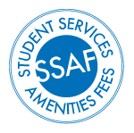
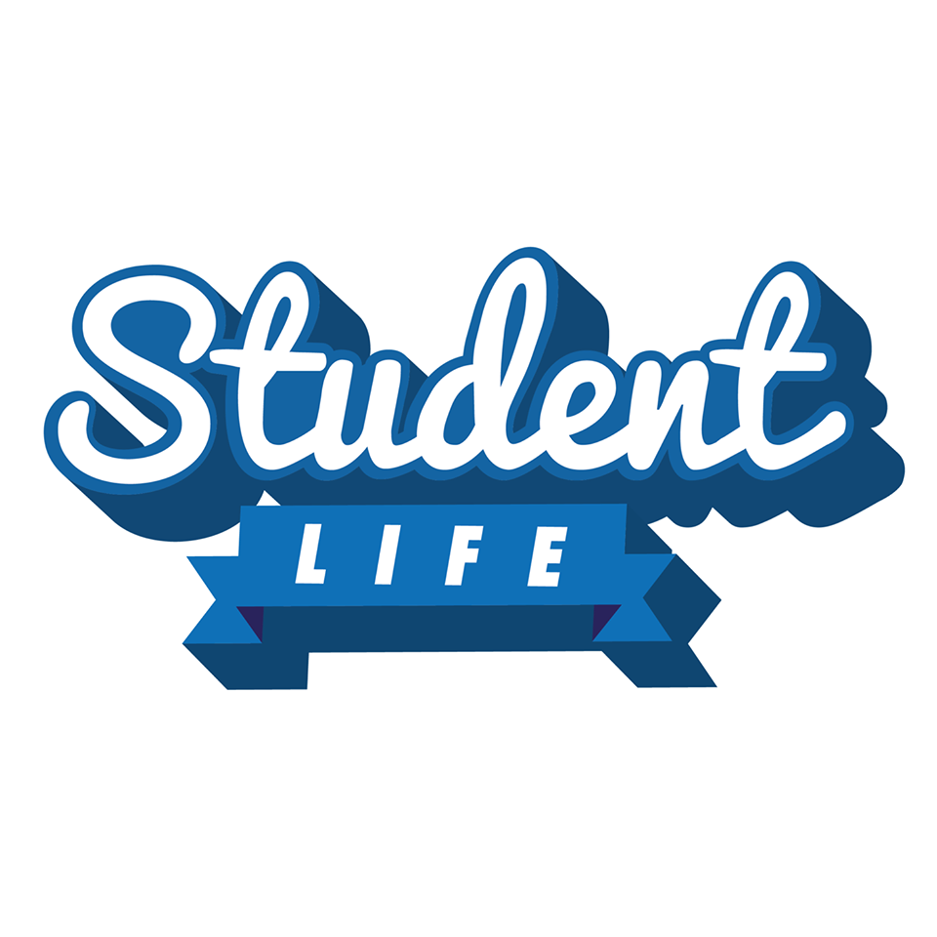

- Overview of the initiative - How did your event go?

- Did your event turn out as expected? Y / N
Please explain what you think went right or wrong.

- Was the attendance as expected? Y / N
How many people attended your event? ______________________________________
  - Did the event happen at the date and time proposed? Y / N

If no, please explain why it was changed and when it was changed to.

- Key objectives / outcomes

- Were the key objectives / outcomes met? Y / N
Please explain how your objectives were/were not met.

- Budget*

  - Was your expenditure as expected? Y / N

If no, please explain whether it was over or under and why.

*(Please provide a copy of receipts attached to this form)

- Benefit to the VU community

- Did your event result in a positive effect on the wider VU community? Y / N
Please describe how your event affected the wider VU community.

- Promotion

  - What were your promotional activities and were they effective?

- Evaluation

  - Do you believe your project was a success? Y / N

Please explain what went right, what the challenges were, and how you dealt with them.

  - Did you achieve or exceed your objective(s)? Y / N

Please explain how you did or didn’t achieve your objectives.

- Reporting

  - Are there any students you will be reporting to? If so, how? Y / N

